What is the distribution of the difference in the resale value of the car (selling price vs MMR price)?
Do most cars sell close to MMR, or is there a large spread?

Sales difference = sale price - mmr

Sales difference describe

count 536433.000000
mean -158.730298
std 1741.067184
min -87750.000000
25% -800.000000
50% -50.000000
75% 650.000000
max 207200.000000
Name: price_difference, dtype: float64

The selling price is 158 dollars less than the mmr.
25% of the cars either sell 800$ below the mmr or 650$ above the mmr.
A car was sold for 87,750$ less than the the mmr - outlier
A car was sold for 207200$ more than the mmr. - outlier

The standard deviation is 1741.0671 which is relatively large compared to the mean. Many outliers.

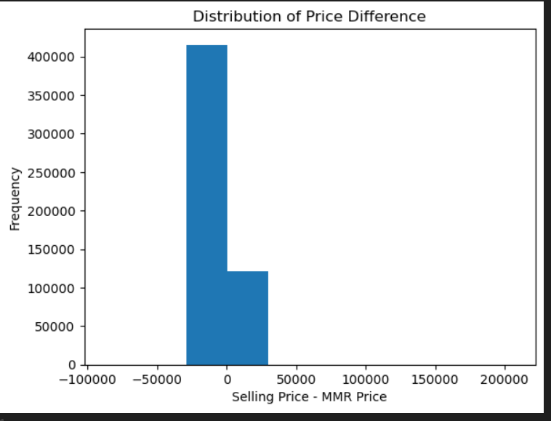
Selling price - histogram
Mmr- histogram

Right skewed.
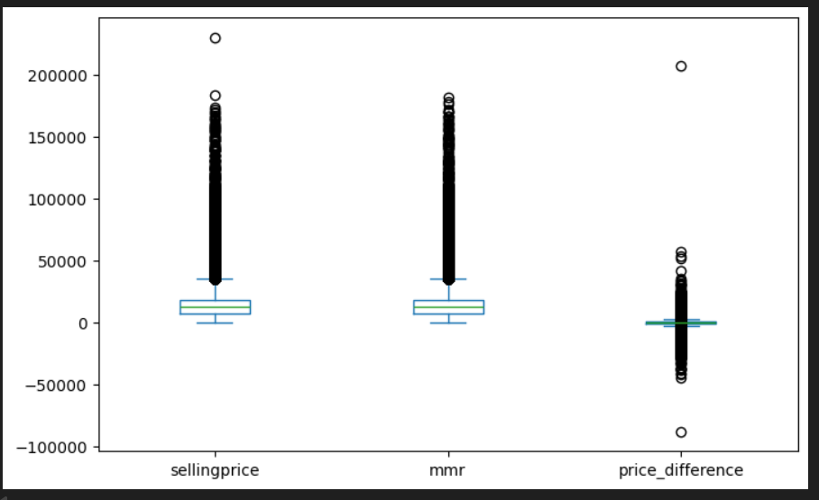

Box plot.

To do:

Find out lower outlier
Find out higher outlier
Reasoning for everything
Count of outliers

